**AZURE ASSIGNMENT**

STEP 1: Creating Resource group(new) and then Virtual Machine

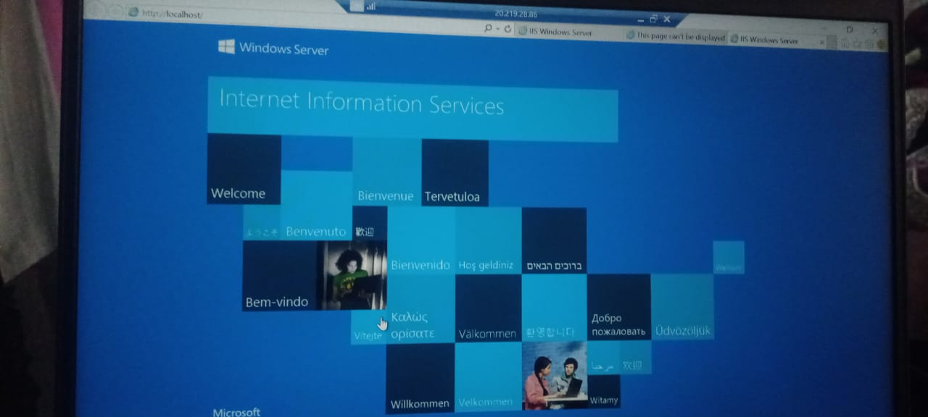

STEP 2: Creation of Virtual network Virtual_Network with 2 subnets (subnet1 and subnet2)

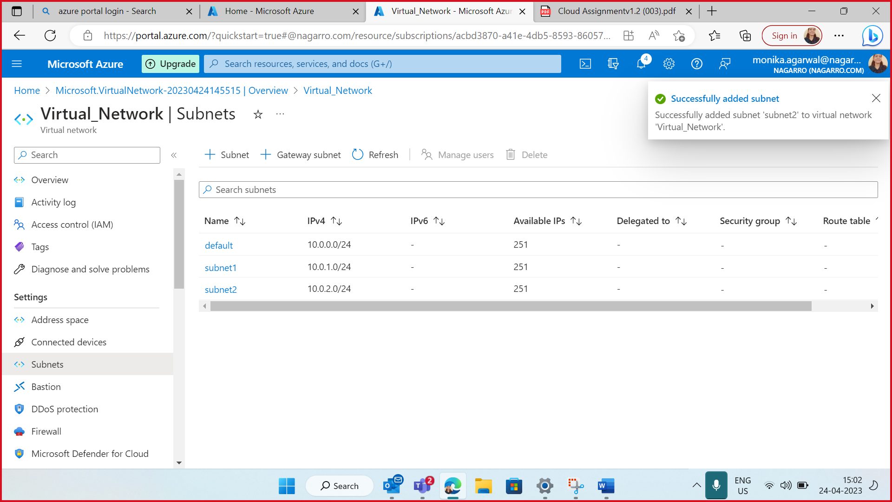

STEP 3: Deploying existing app from visual studio in azure virtual machine

STEP 4: Database creation in database server

STEP 5: Deploying app in azure app service

STEP 6: Creation of Aks cluster (AKSCluster)

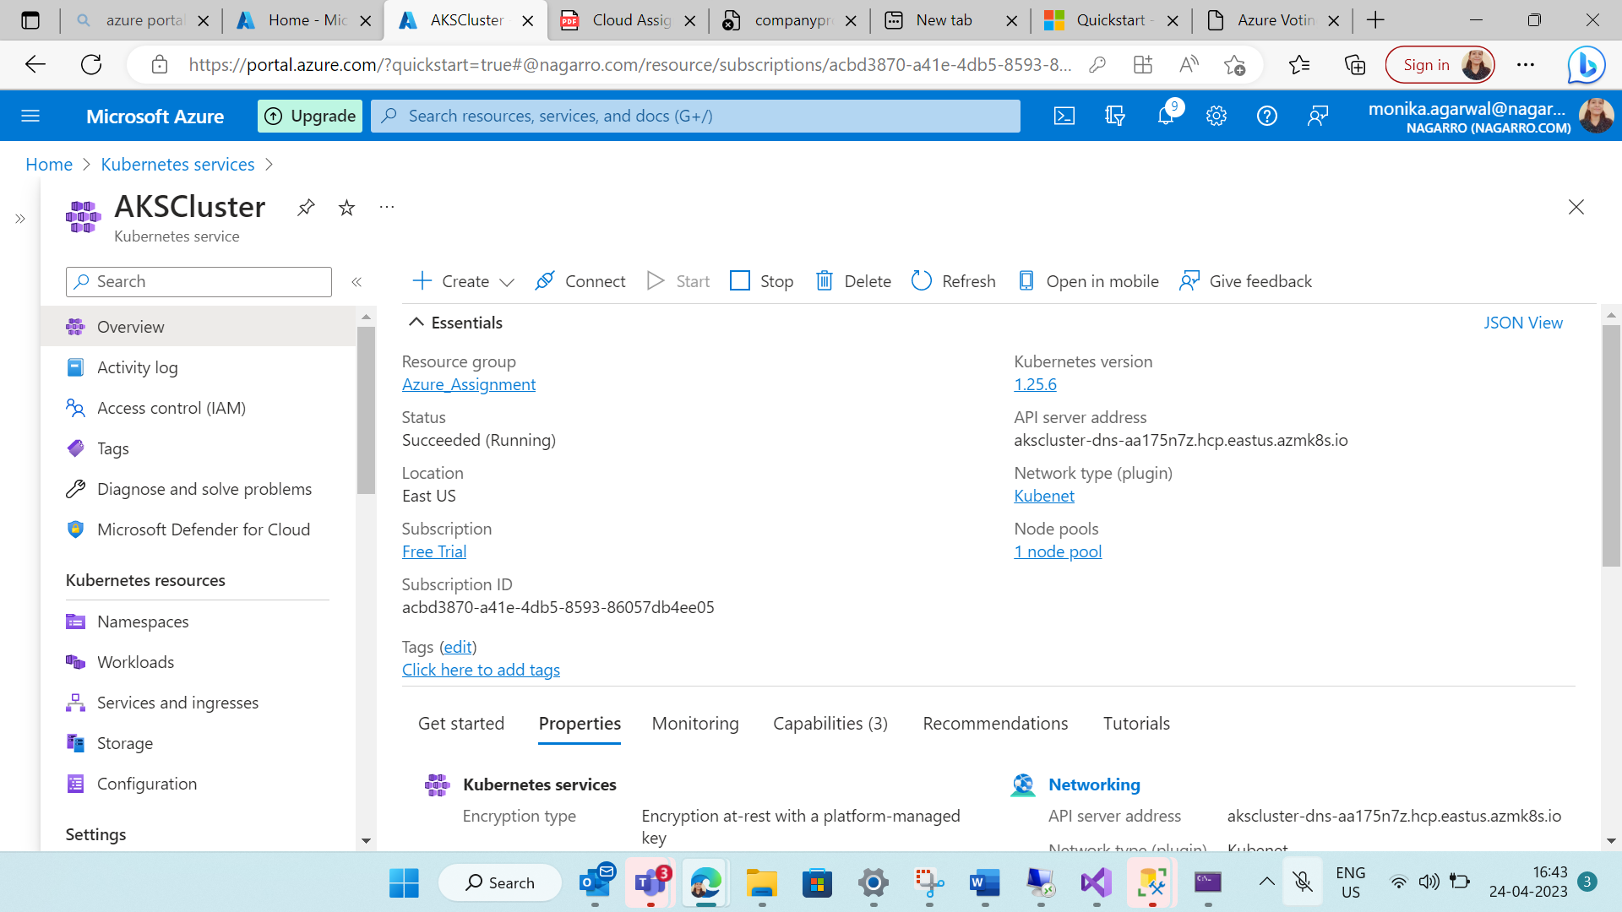

STEP 7: Creating assignment.yaml service using cloud shell

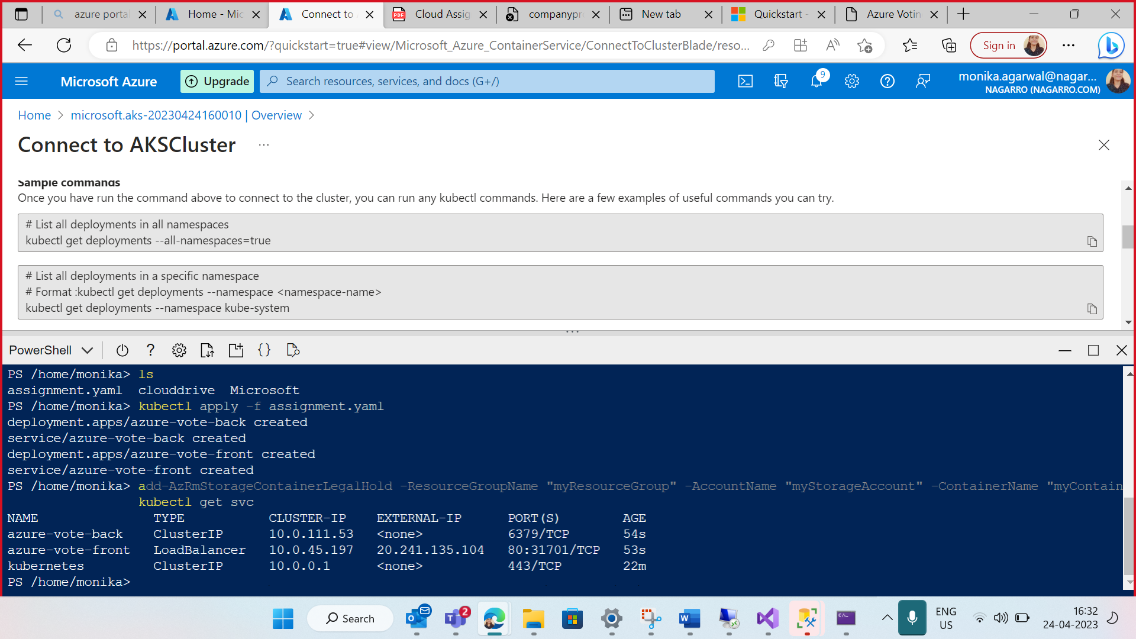

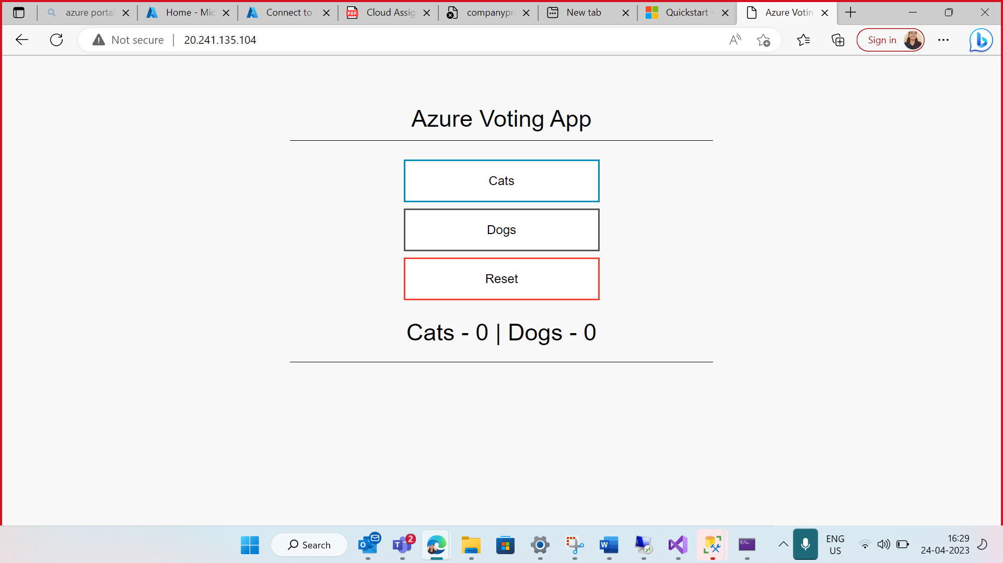

STEP 8: Creating storage function

STEP 9: Function app(monfunction)

STEP 10: creation of blob storage trigger (BlobTrigger1)

Dashboard of my azure account

